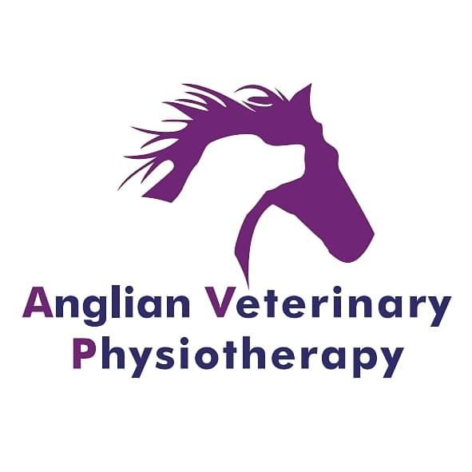**Anglian Veterinary Physiotherapy Privacy Policy**

**What this privacy policy covers**

Anglian Veterinary Physiotherapy is committed to protecting your personal information. In this policy, references to 'we' or 'us' means Sammi Curtis, the owner of Anglian Veterinary Physiotherapy. This notice explains how we collect and use the personal data about you.

**What is personal data**

Personal data relates to a living individual who can be identified from that data. The processing of personal data is governed by the General Data Protection Regulation (the GDPR).

**Information we gather**

As a customer, you will give us information that may include your name, postal address, email address, phone number and details of your animal including full clinical history. We may also hold your browsing history of the content you have visited on our sites, including information on how you were referred to our sites via another website in order to analyse and evaluate our website (www.anglianvetphysio.co.uk).

**How we use your information**

We rely on an explicit consent basis to use your personal information which includes a legal obligation to obtain veterinary consent before treatment can be administered. By filling out the customer consent form you are giving your consent for us to process your information in several different ways. We will never sell, distribute or lease your personal information to third parties. We will only pass on your personal information if we are required by law to do so.

We may use your information for a number of purposes including the following:-

* Compliance with legal, regulatory and corporate governance obligations and good practice.
* To provide you with information about our work or our activities that you have agreed to receive.
* Ensure we know how you prefer to be contacted.
* Keep a record of your relationship with us.

We will use the information you give us to perform services you have requested such as:-

* Being a recipient of veterinary physiotherapy services.
* To send you a reminder of an upcoming appointment by text message.
* To send you a report from physiotherapy appointments which include findings, treatment carried out, and home exercise plans.

**Information Sharing and Disclosure**

We will share your information with your veterinary surgeon and your pet insurers.

**Keeping Your Records**

**All data will be retained for 7 years after the last dated treatment of your animal (s) as specified by the professional organisations; NAVP and AHPR.**

**How We Store Your Information**

We store your information on paper records in a locked cabinet, online systems and in exchange of emails with your veterinary surgeon.

**Your Rights**

You have the right to have any inaccuracies corrected, amended or deleted. If you request certain information that you have provided to be deleted this may prevent us from maintaining adequate records in order to provide a service to you or keep you informed of our activities.

**Enquiries and Contact Details**

By visiting our website and using our services you are agreeing to these policies. If you have any questions or concerns about the privacy policy, or our practices with regards to your personal data, please contact Sammi Curtis at [anglianvetphysio@gmail.com](mailto:anglianvetphysio@gmail.com) or call 07775161526.

By signing below you agree to Anglian Veterinary Physiotherapy’s privacy policies.

Printed name ………………………………………………………….

Signature ………………………………………………………………… Date ……………………………………….